YAMAHA XR 565 MATRIX

12 Pin Connector

Black Cable on PIN 11

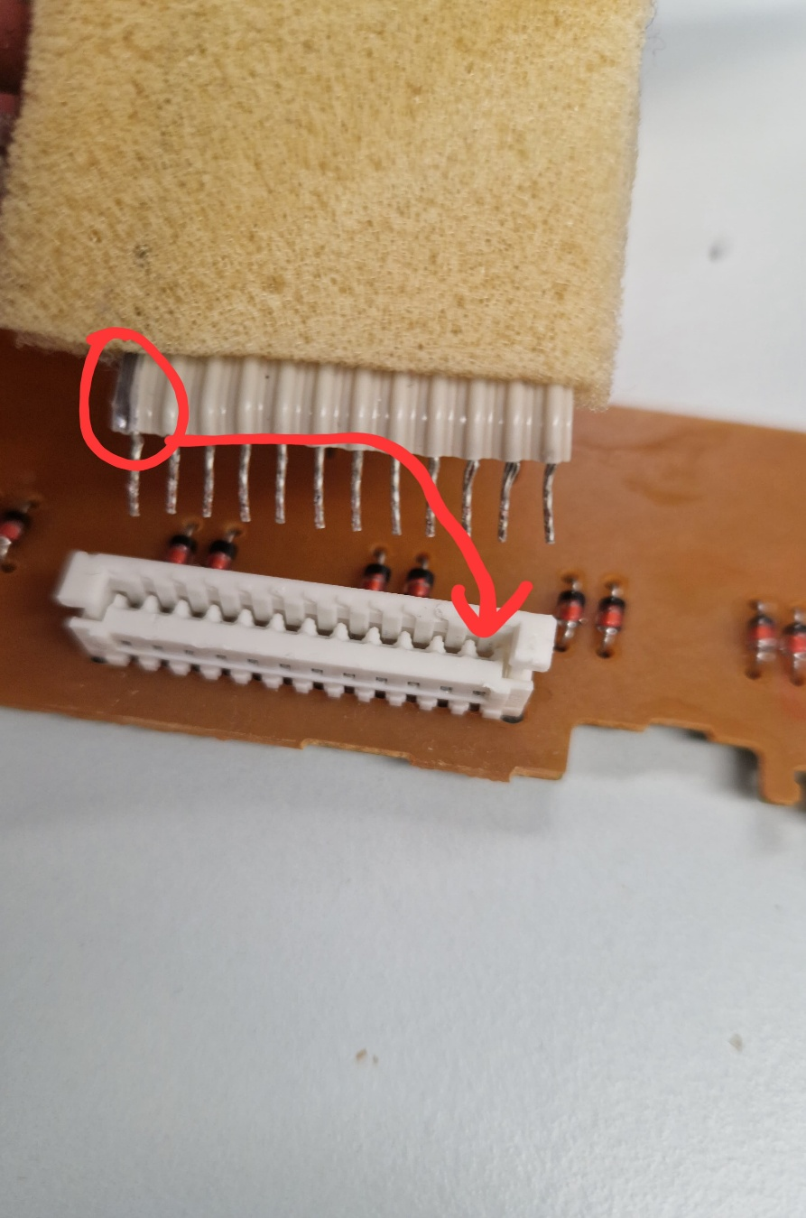All Pushing power through



5 Pin Connector

Black Cable on PIN 28

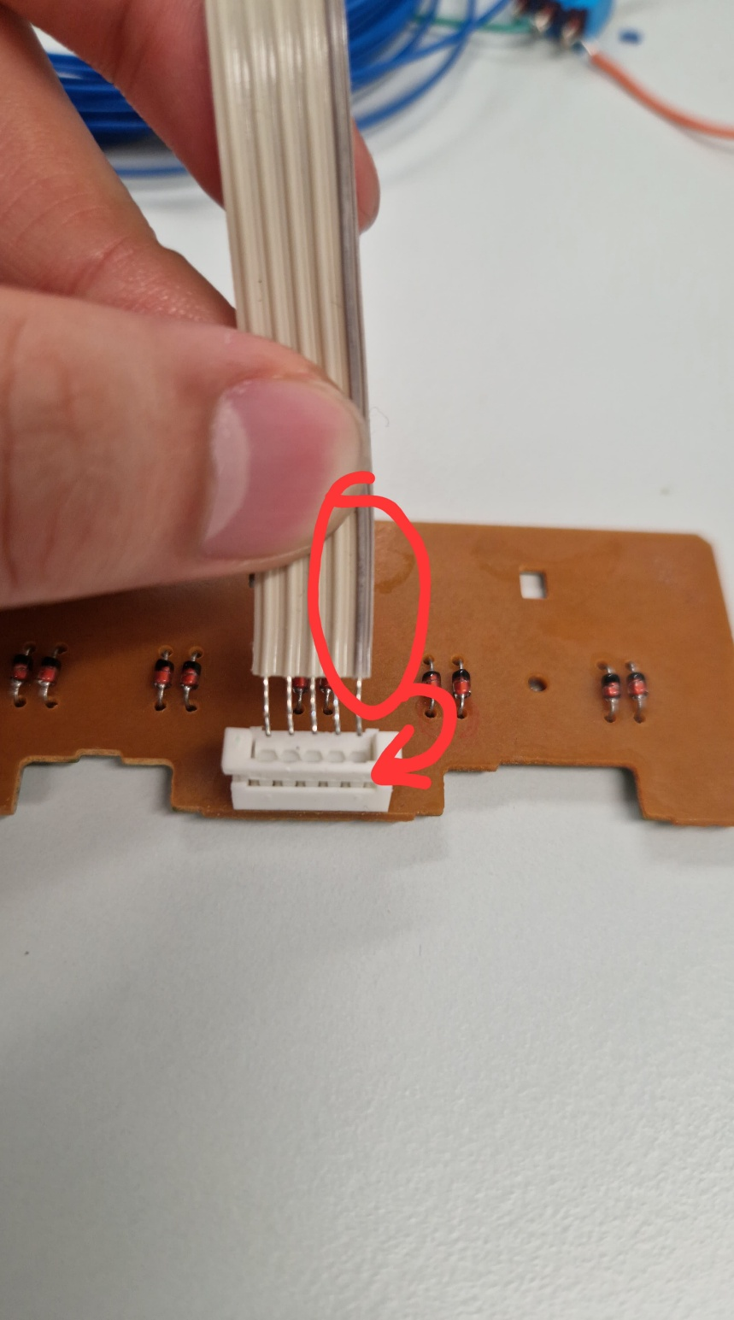LOW PULL